ProjectorBI Help Documentation

This document outlines a number of common tasks and requirements around ProjectorBI. Particularly the steps to embed a report into Projector, how to add fields to Projector reports, or add entirely new reports to the dataset.

Table of Contents
Know Where to Go 3
Grant Access to Users to View Visualizations 4
Share the Reports / Visualizations 5
For Organization and Homepage Dashboards: 5
For Workspace Dashboards- 6
To Download the .pbix File from the Power BI Workspace for Editing 7
To Upload the pbix file to the Power BI Workspace 9
Adding Fields to ProjectorBI Datasets 10
Adding Additional Reports to ProjectorBI 12
Common Troubleshooting 14

Know Where to Go

Projector Management Portal  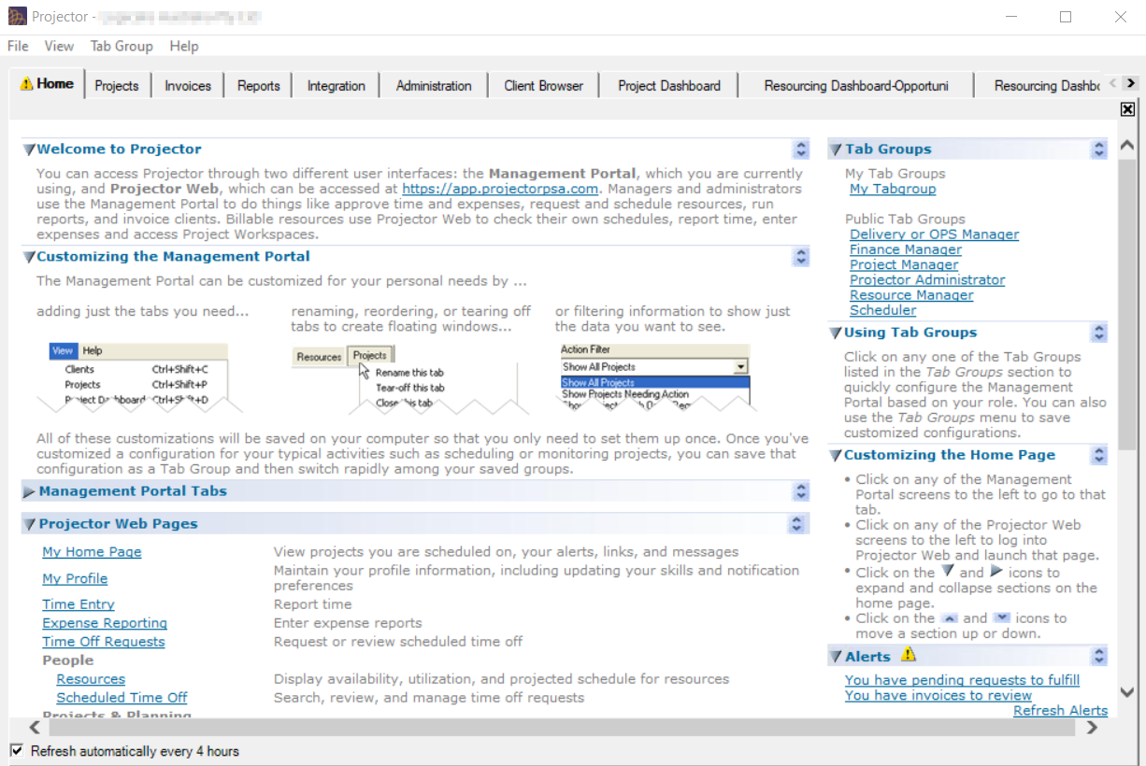  - Grant overall BI access to users  - Share organization or home page visualizations (User Types)  - Share project workspace visualizations (Engagement Types or individual projects)  - Update Projector reports that feed the dataset | Projector Web  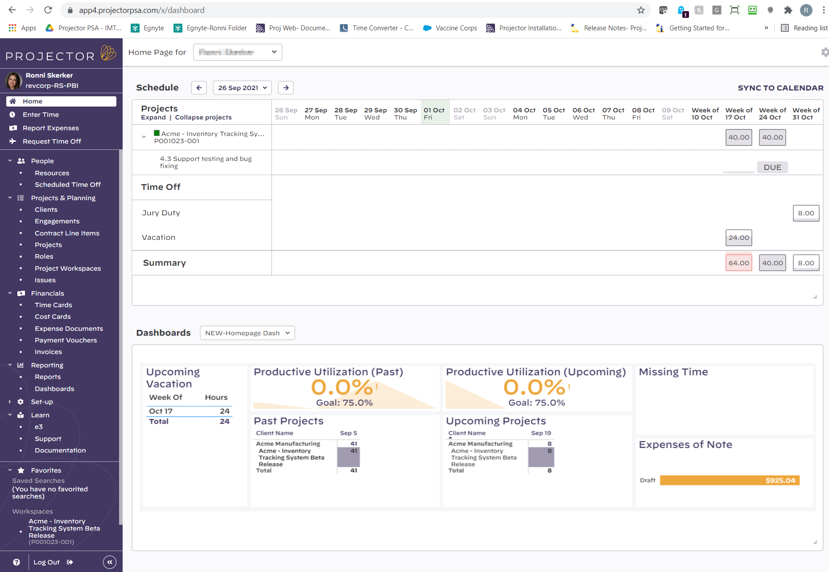  - View BI content, including home page, project workspace or corporate visualizations  - Share project workspace dashboards for individual projects  - Update Projector reports that feed the dataset
Power BI Desktop  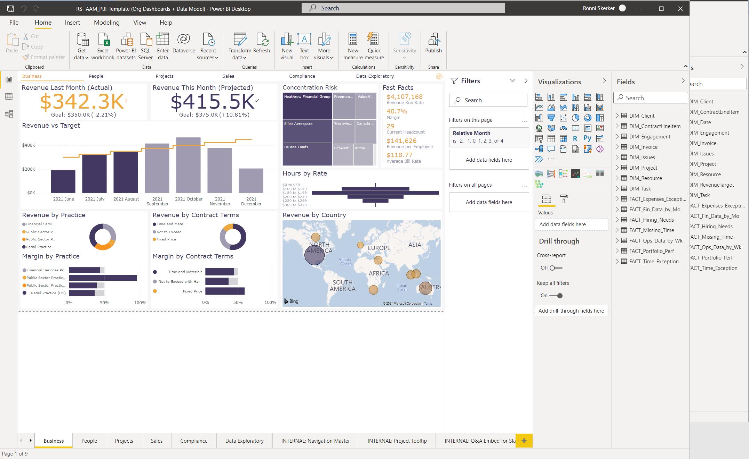  - Update Power BI reports and / or the data model  - Add report content (visualizations) | Power BI Service (aka Workspace)  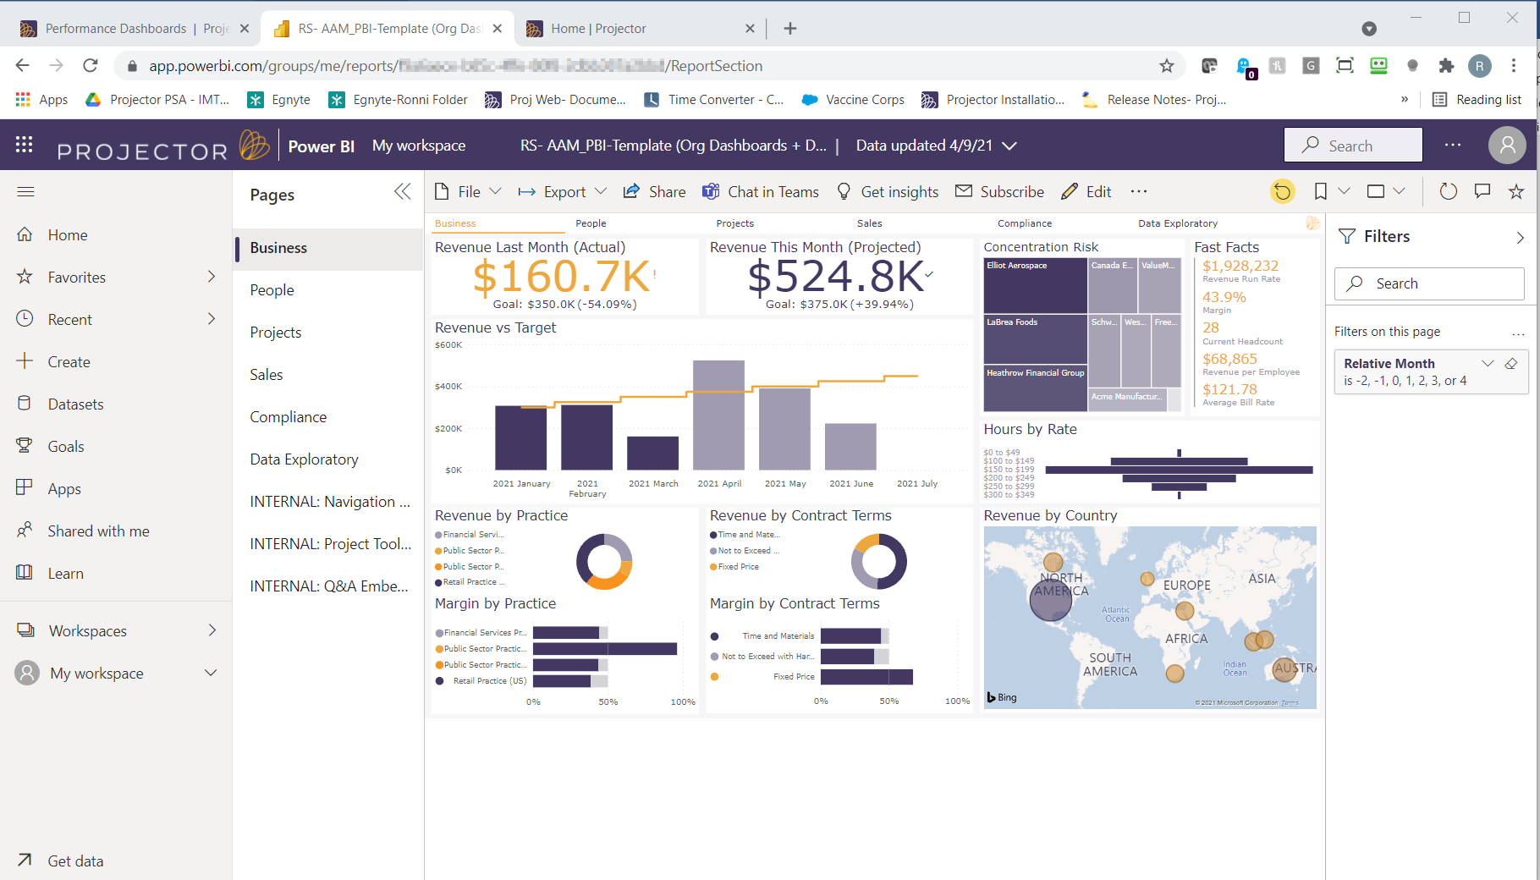  - Administer Projector BI (download most recent pbix for updates; upload pbix to be shared)

Grant Access to Users to View Visualizations
By "User Type" or "User", users must be explicitly configured to "View Projector BI content"-

Options are
- View Projector BI Content
- Not View Projector BI Content
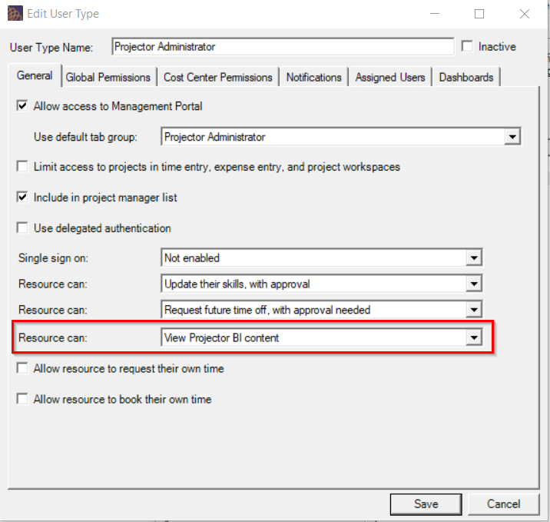

When Organization and Home Page dashboards are shared, they are shared by “user type”. This Account setting determines whether sharing is based only on the “primary user type” or based on all “user types”.
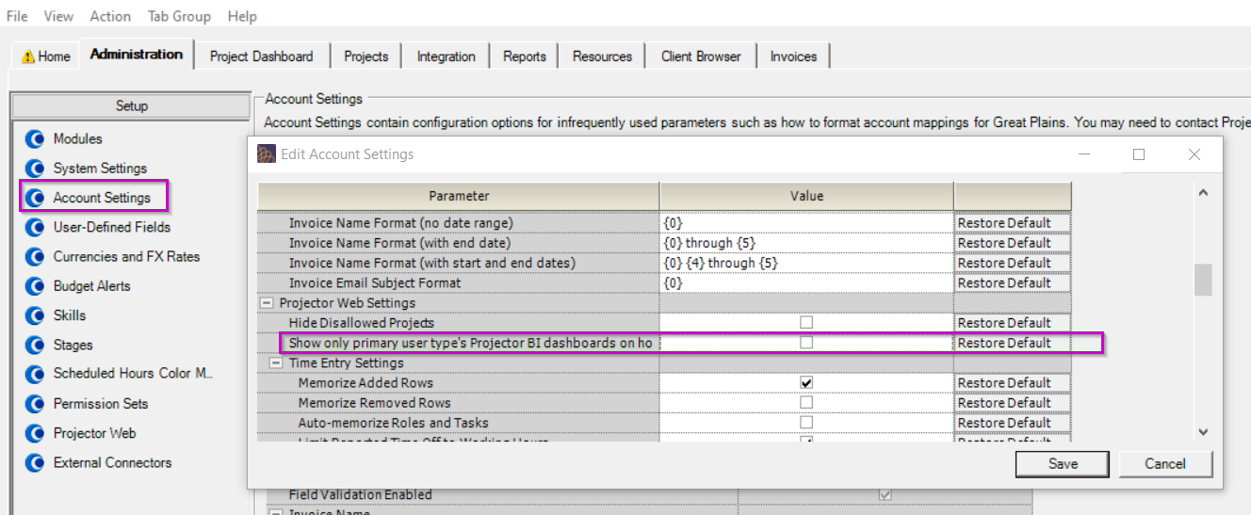

Share the Reports / Visualizations

For Organization and Homepage Dashboards:
Example- Organization-
Details for Workspace ID, Report ID and Report Section come from the URL in app.powerbi.com and get entered in Projector, along with any needed filter parameters

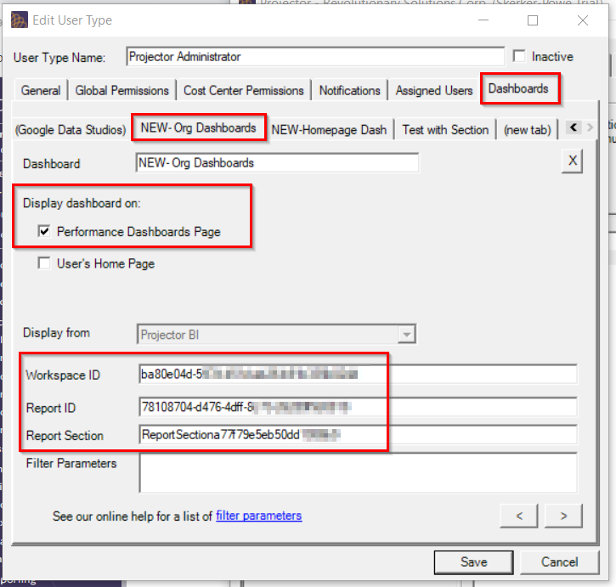

Example- Home Page-
Left-most home page dashboard shows as default

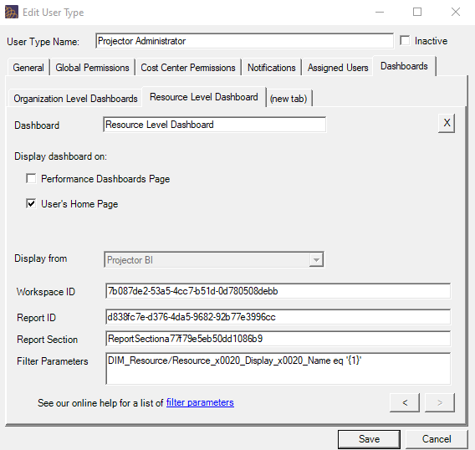
Example Resource specific dashboard
Filter: DIM_Resource/Resource_x0020_Display_x0020_Name eq '{1}'

For Workspace Dashboards-
Workspace Dashboards can be Set up Either within the project on the Workspaces tab or by Engagement Type- (the UI is the same)
The same UI allows you to set who has access based on their project role
Filter: DIM_Project/Project_x0020_Code eq '{0}'

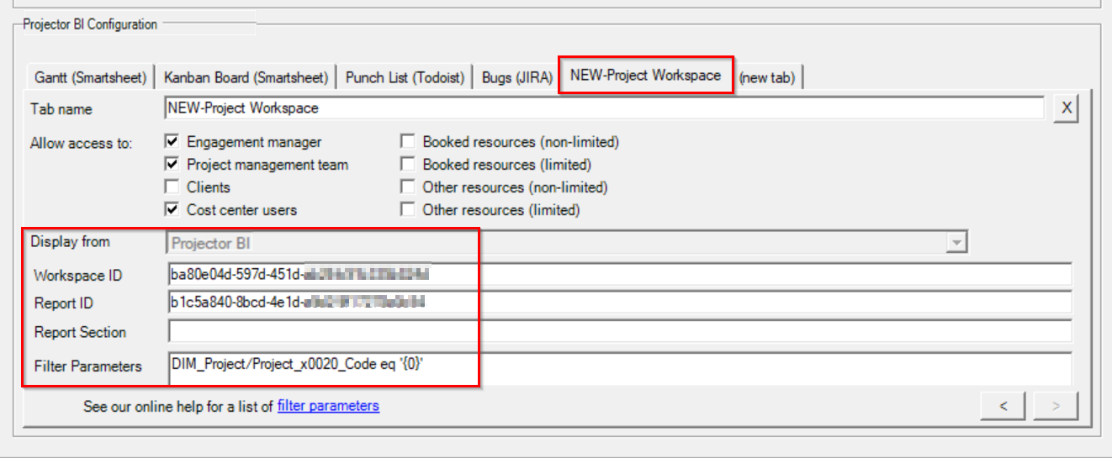

To Download the .pbix File from the Power BI Workspace for Editing
From within the power BI report in the workspace, choose the option to download the pbix file.
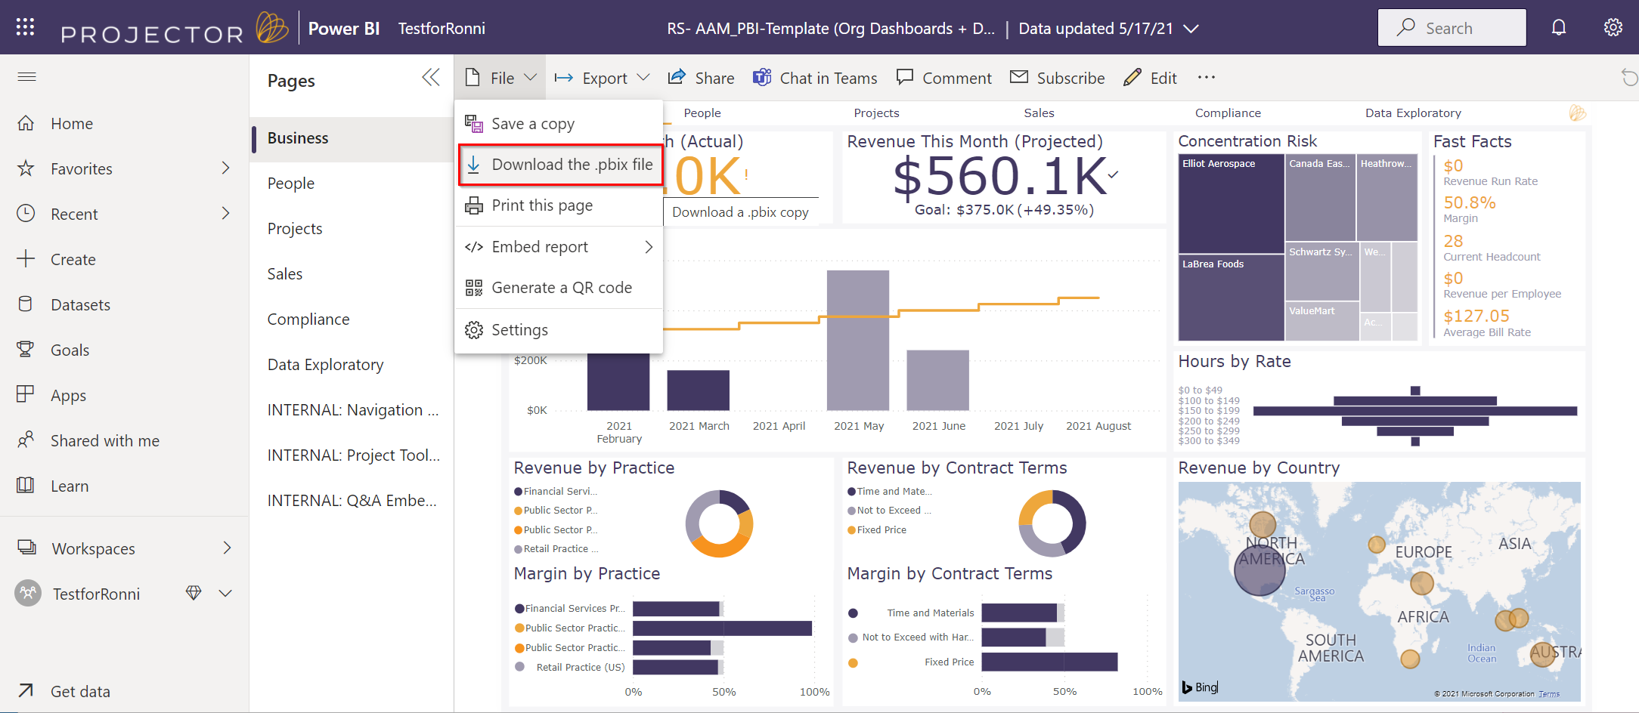
This message indicates that the file is being downloaded:
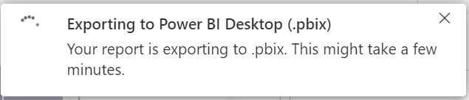
Once downloaded, the file can be modified in Power BI desktop. It’s important to keep the file name the same (for re-uploading), but Projector recommends keeping dated backup copies to ensure that the latest version is uploaded to the workspace.

To Upload the pbix file to the Power BI Workspace
From the workspace main page, choose the option to “Upload a File”
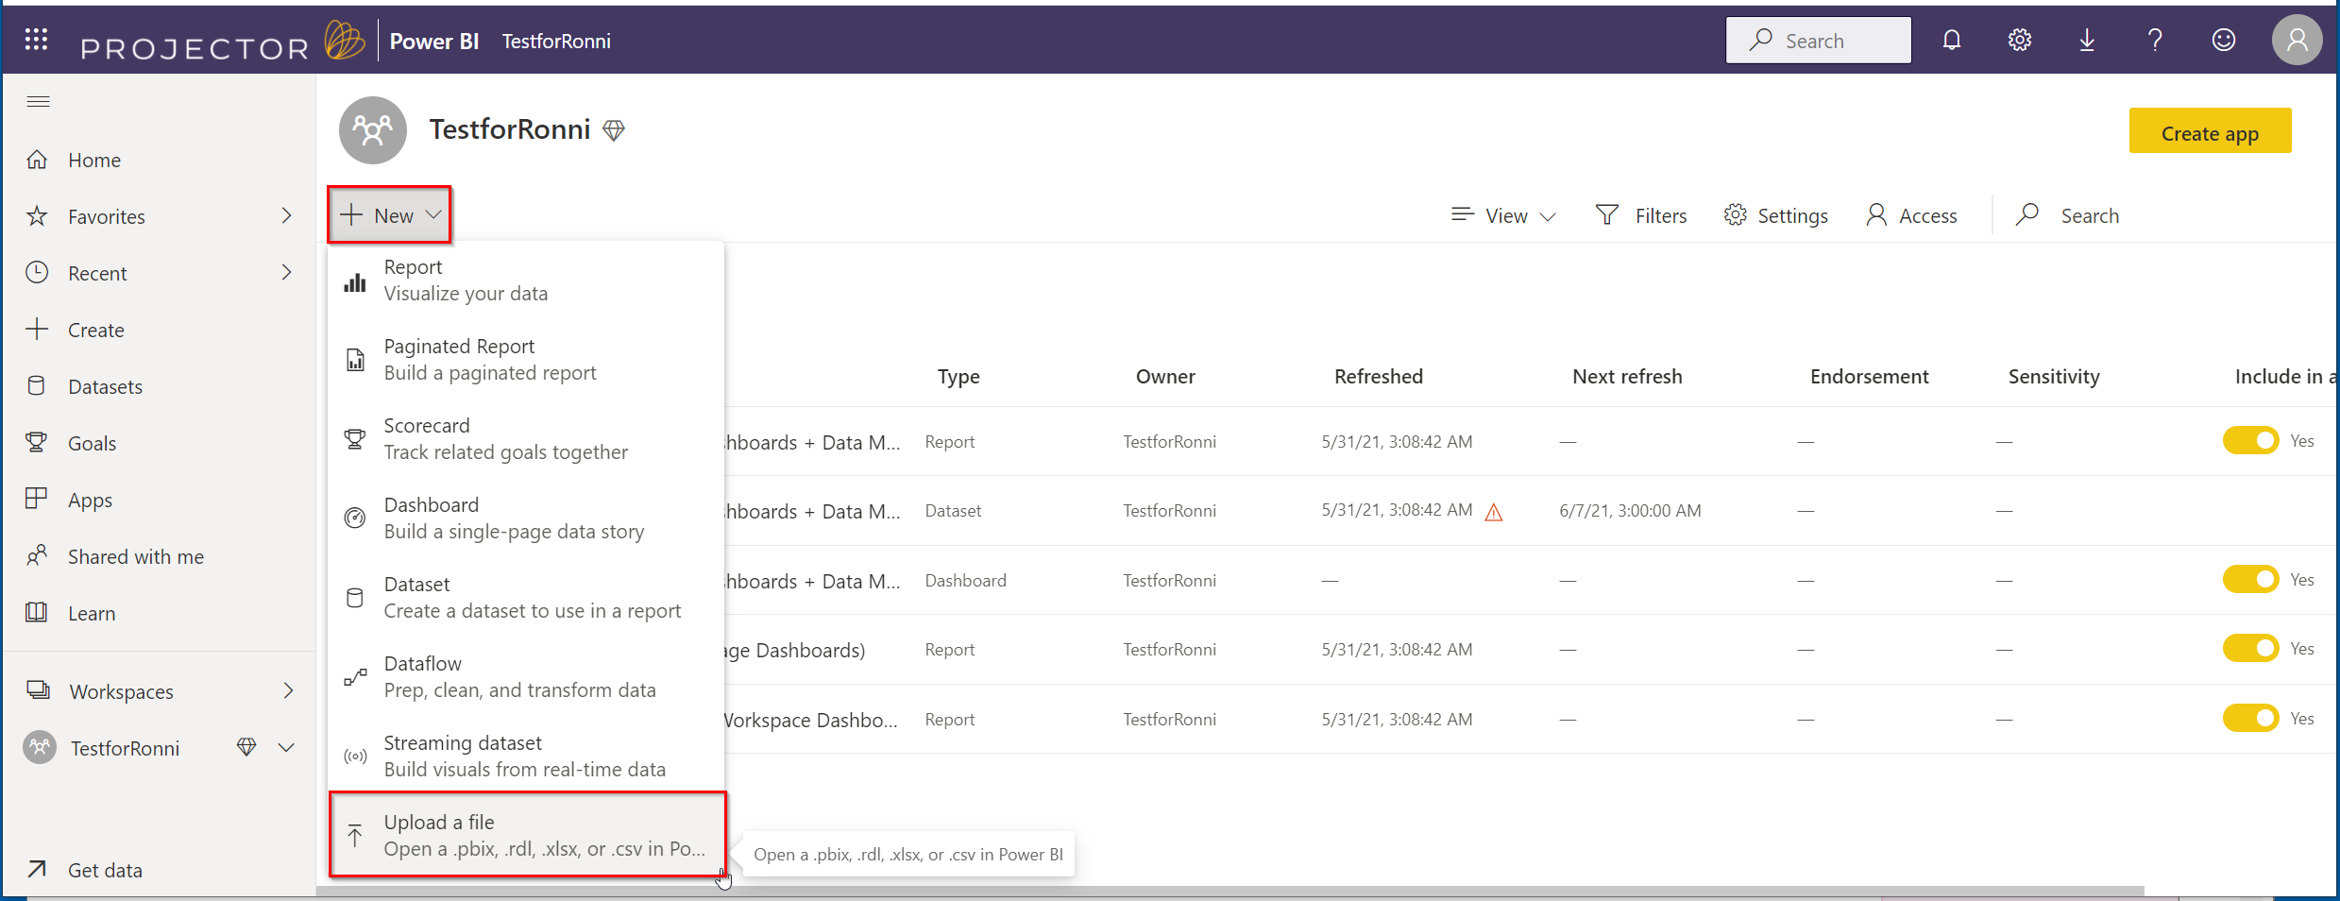
Since the file is stored locally, choose this option
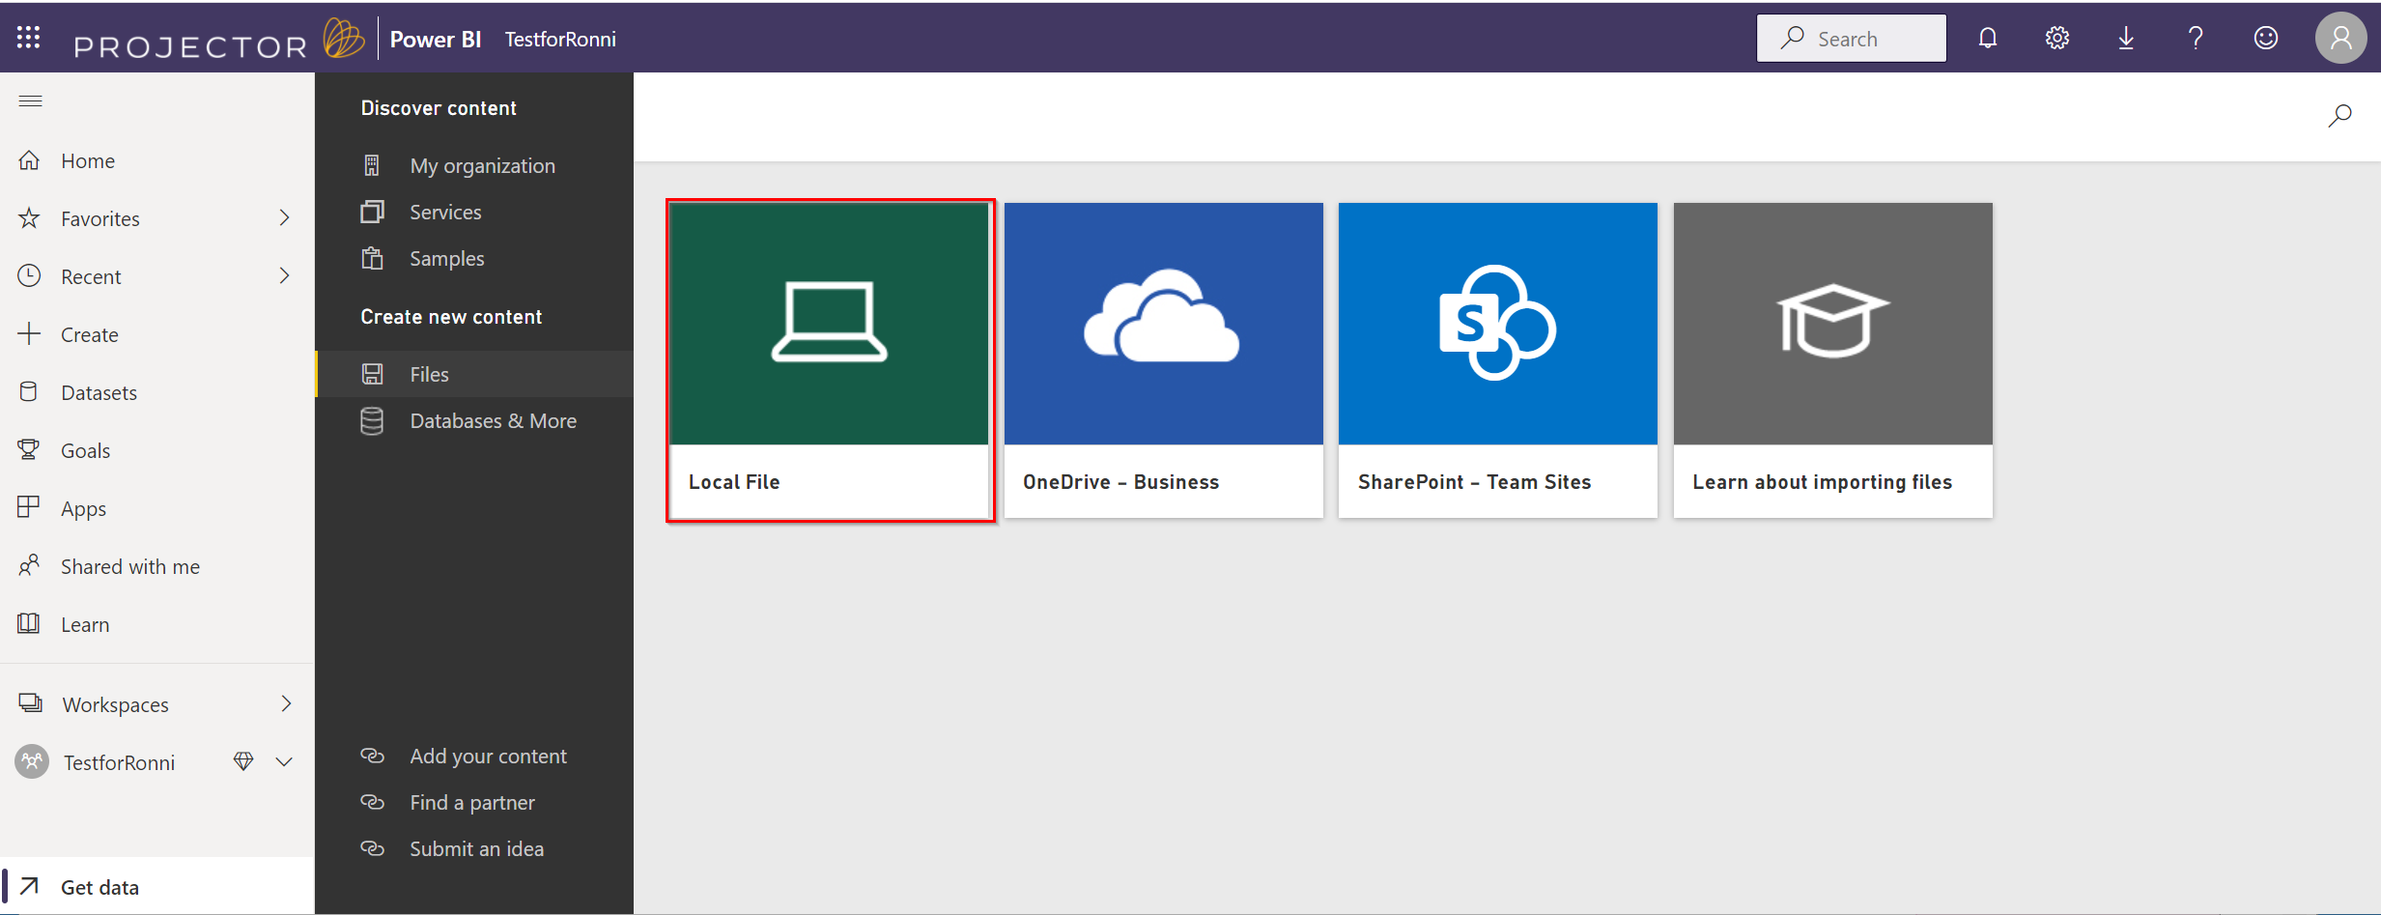
Select the file and make sure to keep the same file name, so that the file is replaced and not added.
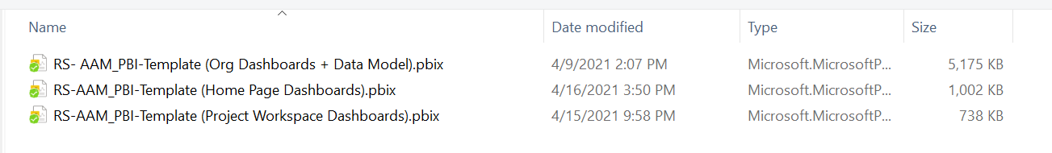
You will get this warning message
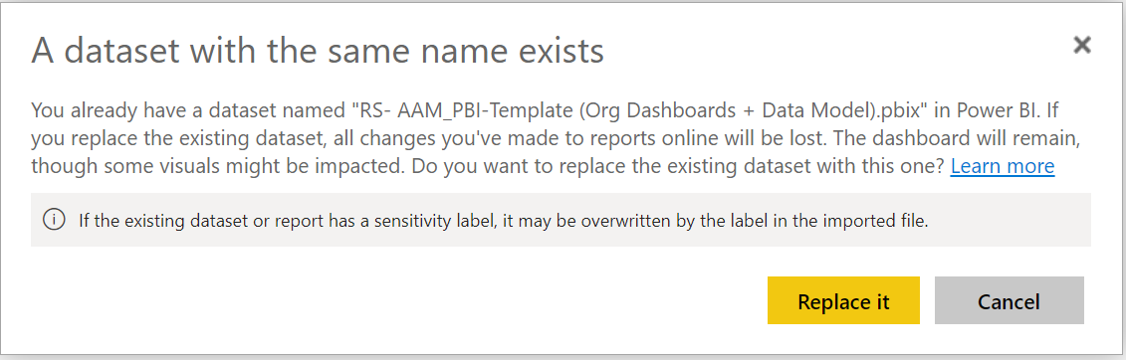
Once the file is uploaded, the data will attempt to refresh. Be sure to check that the refresh was successful. If there is an error with the refresh, it will appear as an icon here.
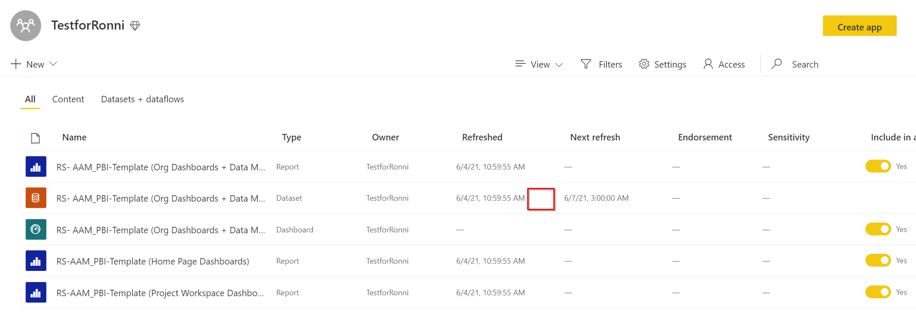

Adding Fields to ProjectorBI Datasets
You may find you need additional fields in your ProjectorBI environment. To do so you’ll first need to add them to the underlying Projector Reports.
Do this from the Projector reporting interface. You’ll need to sign in as whatever user owns the scheduled reports. PPSA recommends this be a generic user.
Open the report that needs additional fields and add the fields:
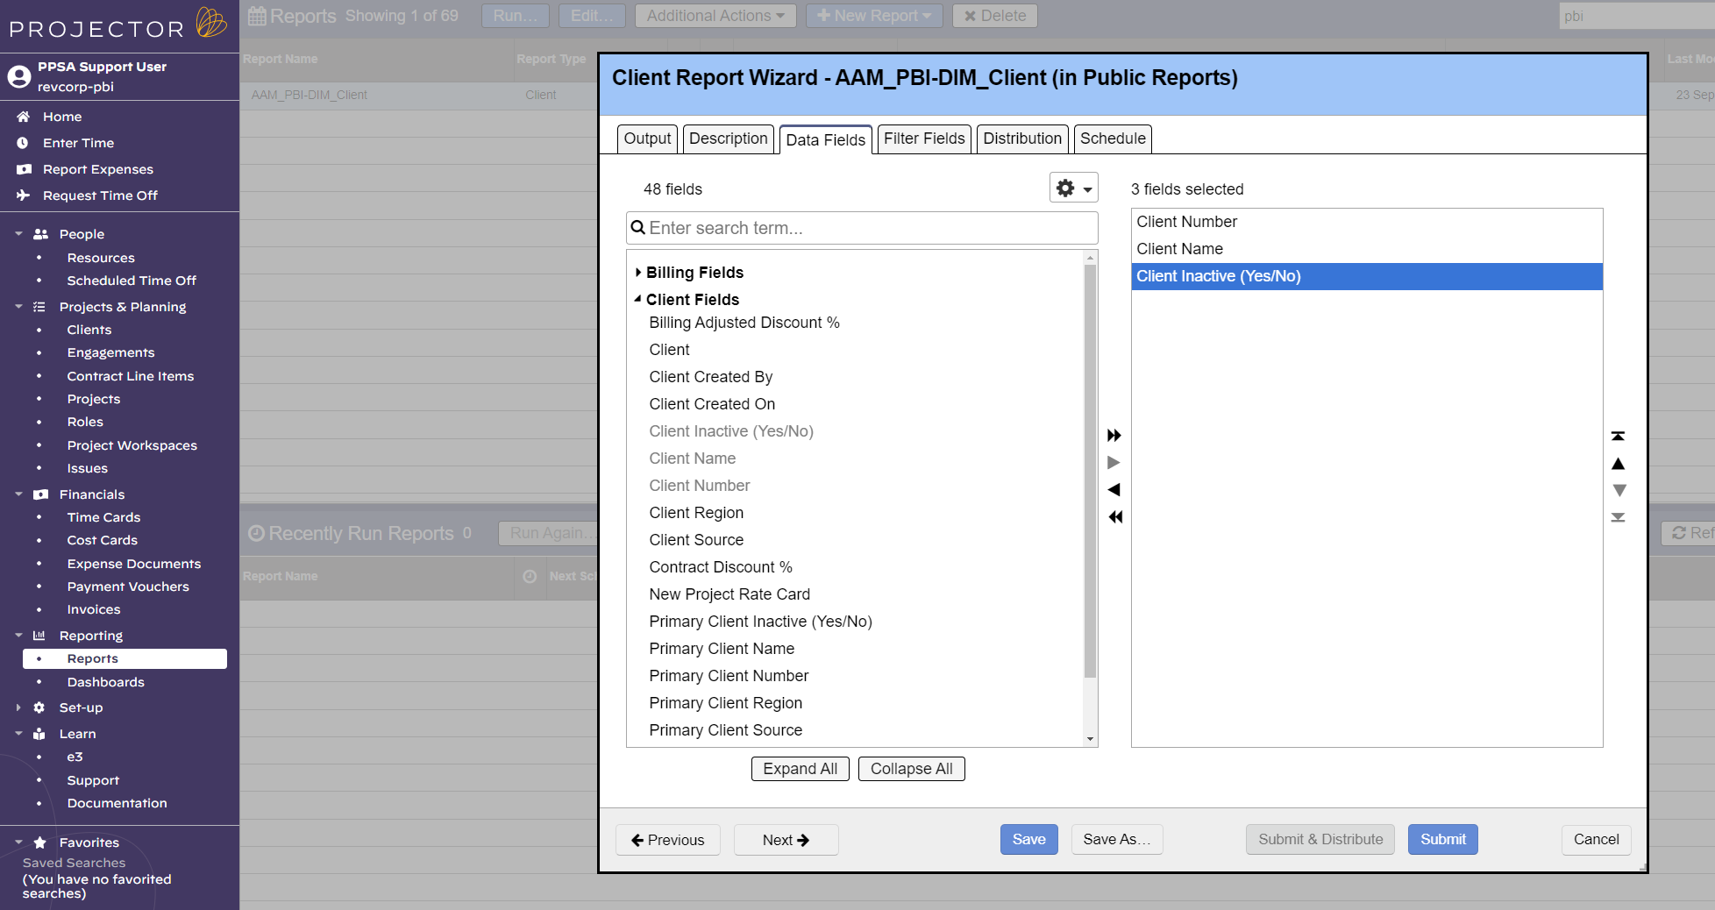
The trick here is to remember how many fields you added. In this case I added one field.
Now go to PBI Desktop and Transform the data. Transform will open Power Query. Select your query or dataset and select Advanced Editor.
From the Advanced Editor you need to tell PBI to expect additional columns. Overwrite the hardcoded column count here by adding the fields you’ve just added with the existing fields. In this case my query has gone from 2 columns to 3 columns.
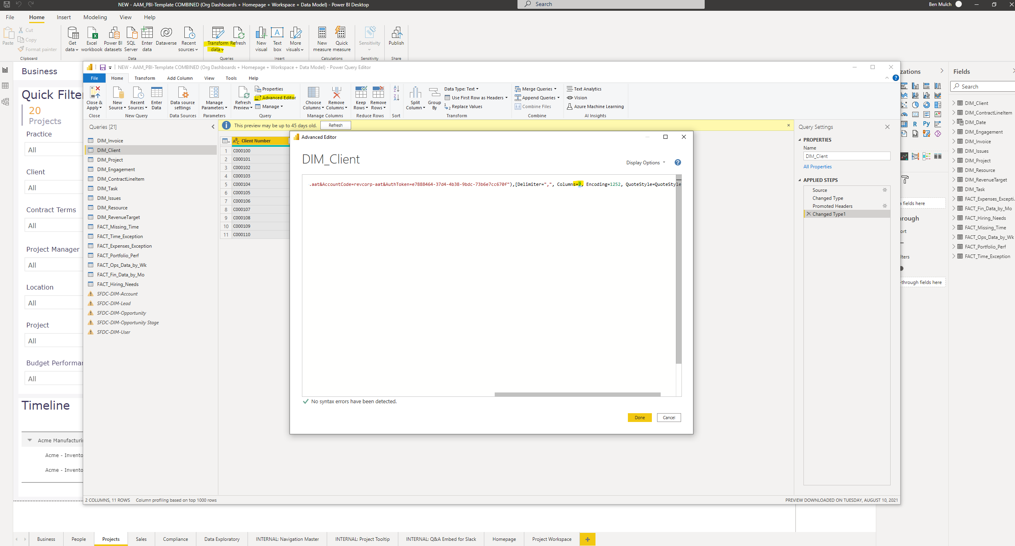

Save and Apply your changes. This method can be used to add data fields or row fields to any Projector report.

Adding Additional Reports to ProjectorBI
You may also find that you need entirely new reports added to your dataset. To do this create the new report in Projector:
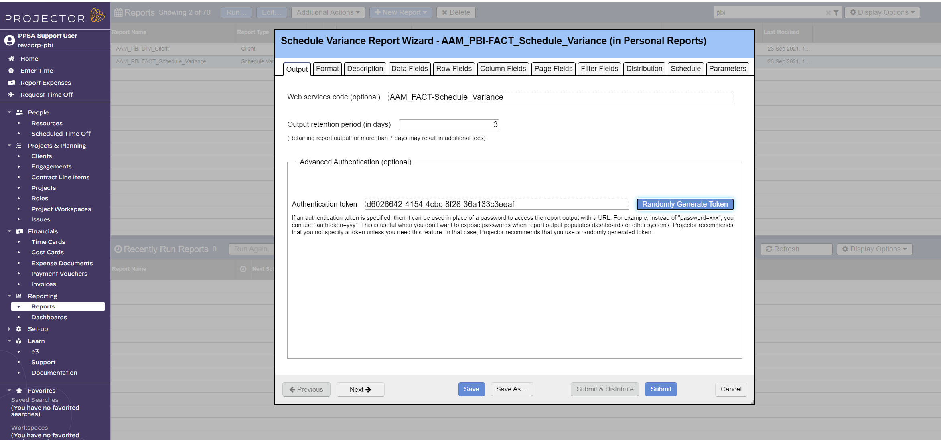
Be sure to give the report a useful name and copy the authentication token from the other reports. You’ll also want to set up a schedule for this report that makes sense with your other ProjectorBI reports.
Once your is ready submit the report. On the completed report select “Show Output URL…”.
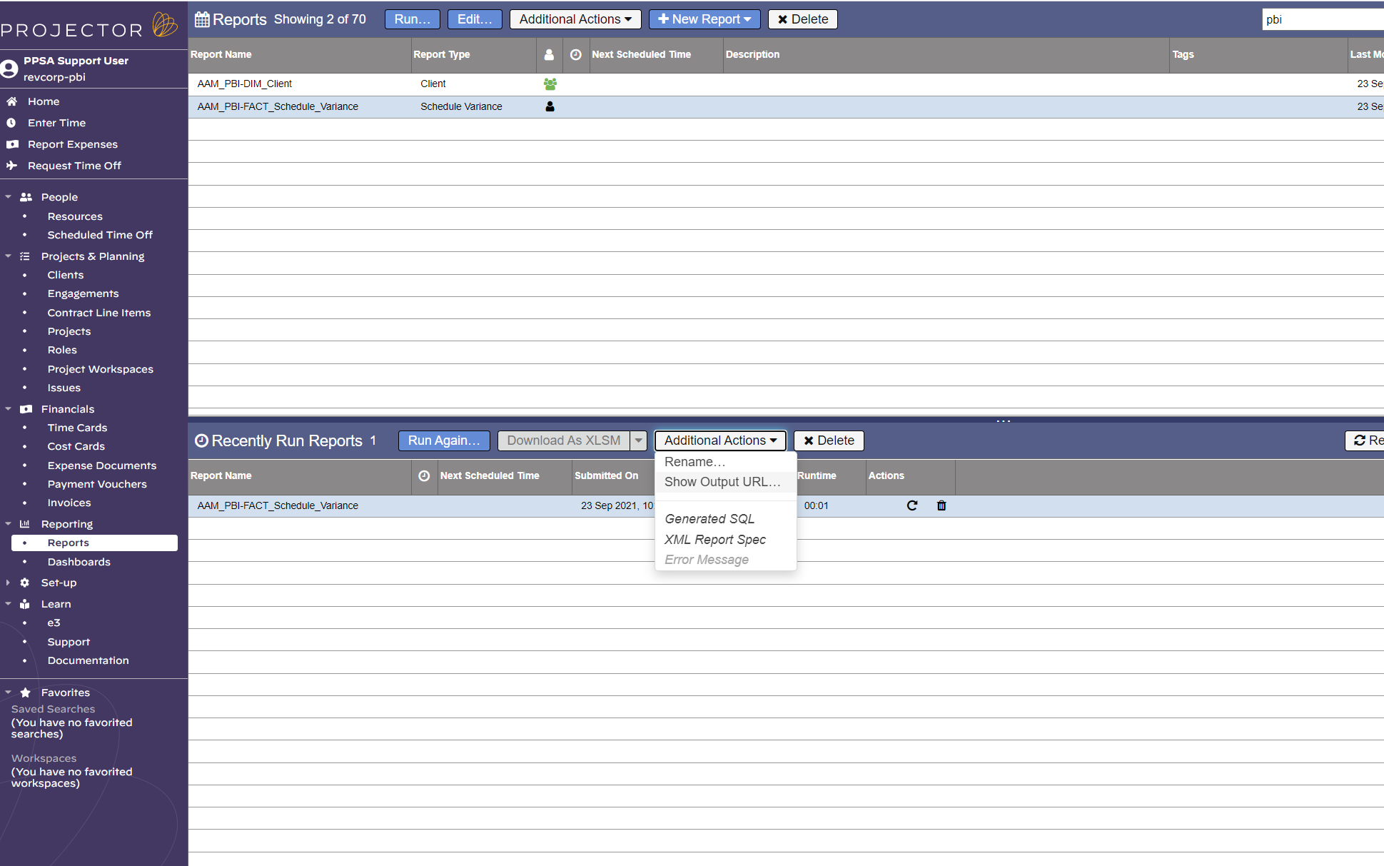
From here copy the csv output url. This is the url that will point PowerBI to Projector’s web services to retrieve the report.
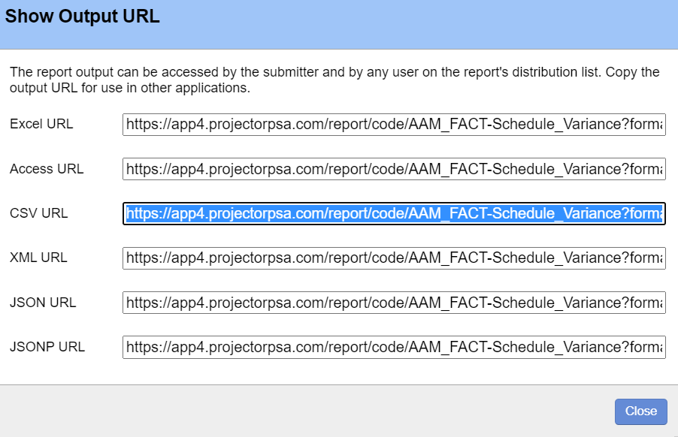
Now in your PBI Desktop file select “Get Data” > “Web”:
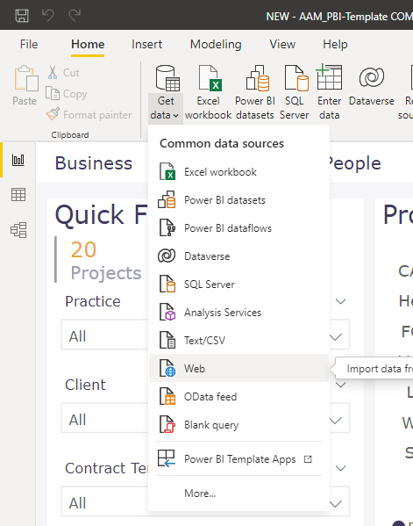
Drop the CSV URL in the following popup. Add the suffix "&IncludeEmpty=yes" to any reports that could hypothetically come back empty.
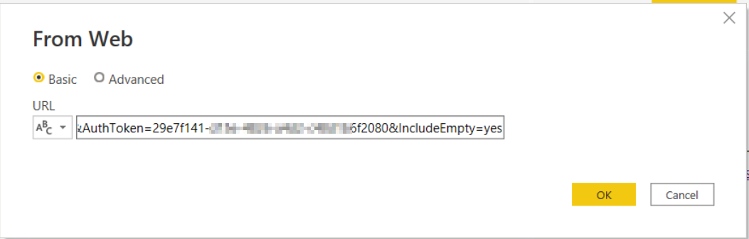
PowerBI will show you a sample of your data. From here you’ll likely want to “Transform Data” to finish building out this dataset.

Common Troubleshooting

Commas in Project Descriptions
Sometimes a report will break because of duplicates in an unexpected data set (generally DIM_Project). This is caused by comma’s in the Project Description field. The simple fix here is to open the Data Source Settings, navigate to your report, and select “Change Source”:
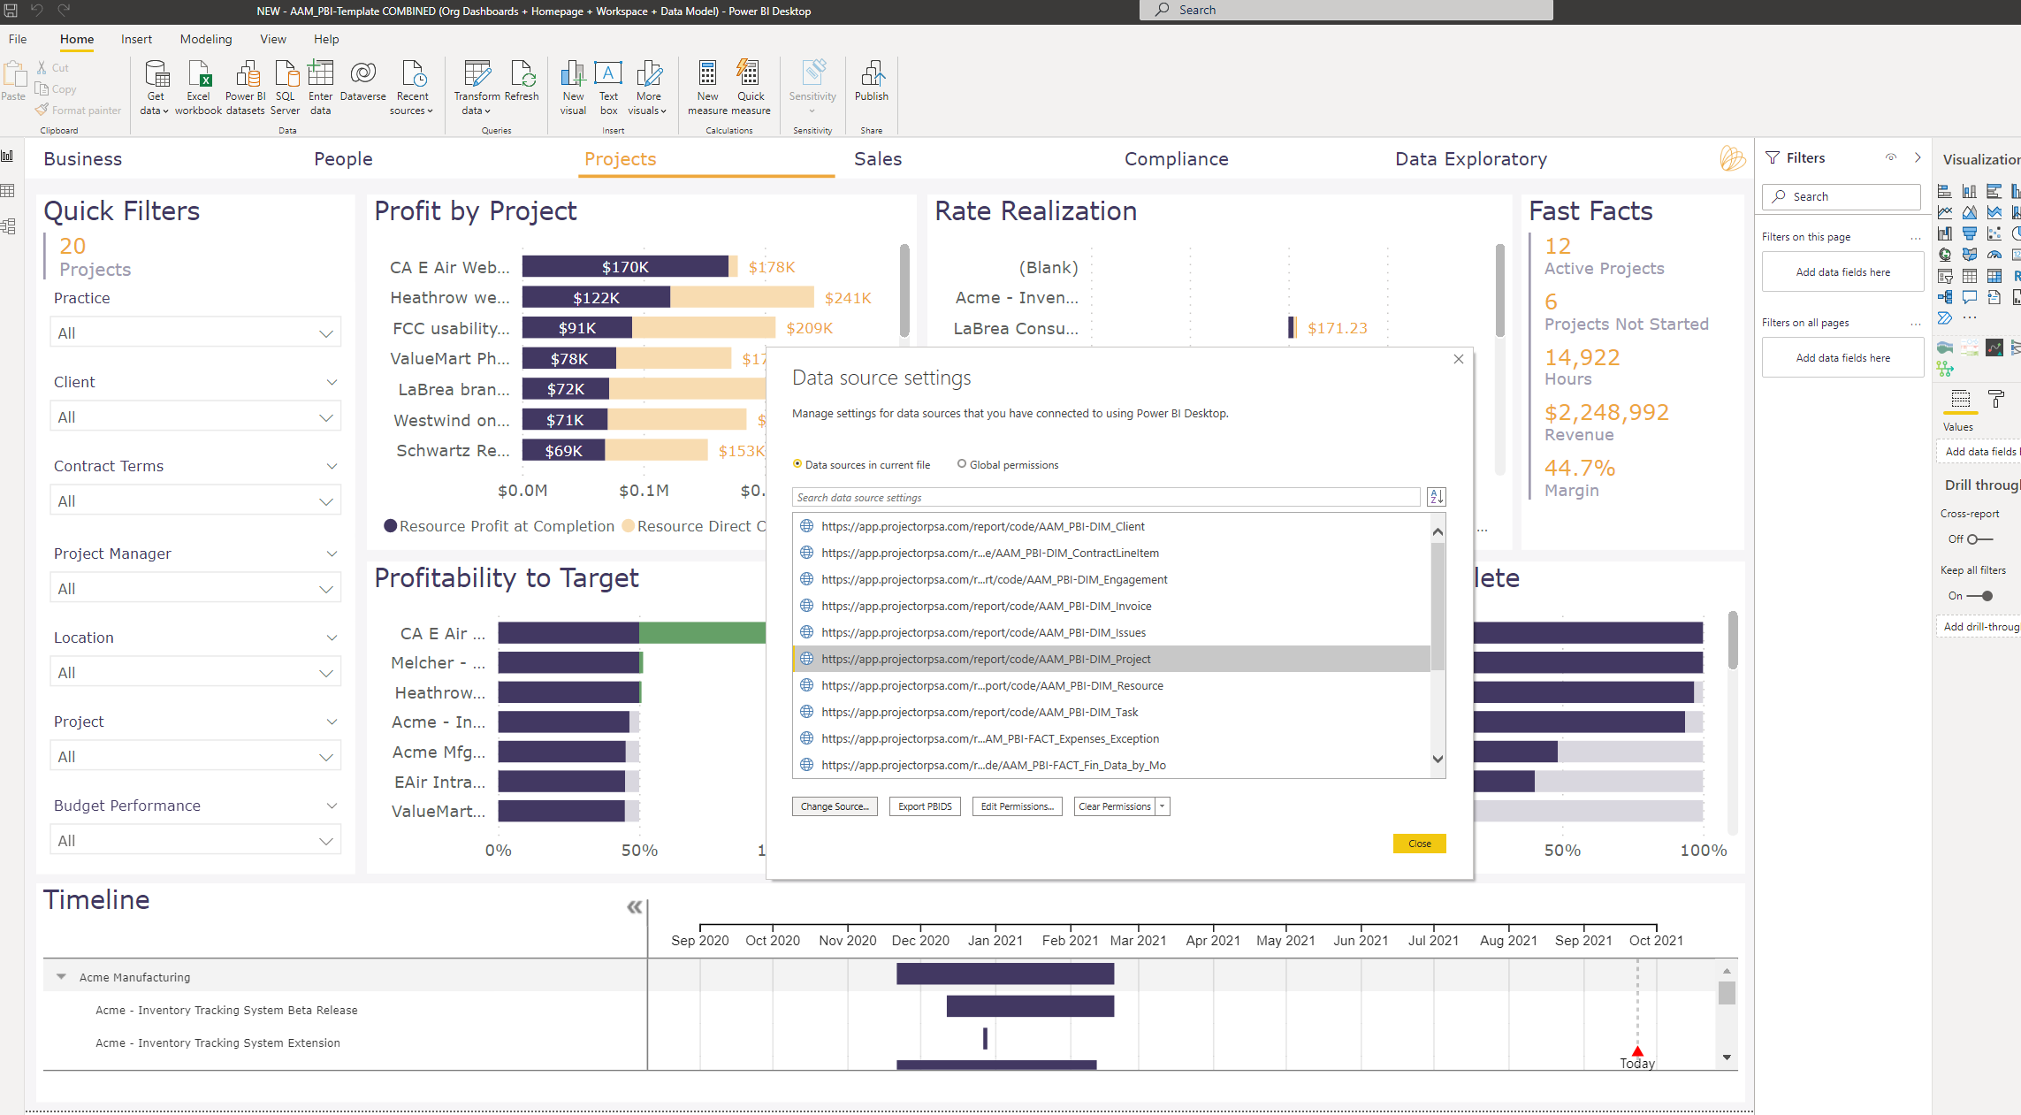
In the setting change the “Line Breaks” drop down to “Ignore quoted line breaks”.
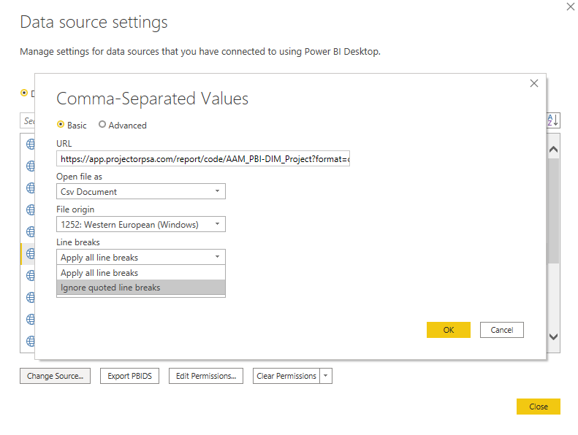
Save and apply.

